

American International University-Bangladesh (AIUB)

**Thesis**

**A Hybrid Model: Software Risk Identification and Software risk Analysis in Bangladesh IT Industry**

**Submitted By**

|  |  |
| --- | --- |
| NAME | ID |
| TANIA RAHMAN | 17-33841-1 |
| SHANTO KUMAR SAHA | 17-34699-2 |
| MD. TAMIM MAULA | 16-32586-2 |
| MD. SAJJADUR RAHMAN SOHEL | 17-34017-1 |

Department of Computer Science

Faculty of Science and Technology

American International University Bangladesh

**20 May, 2021**

**DECLARATION**

We declare that this thesis is our original work and has not been submitted in any form for another degree or diploma at any university or other institute of tertiary education. Information derived from the published and unpublished work of others has been acknowledged in the text and a list of references is given.





|  |  |
| --- | --- |
| _______________________________  **Rahman, Tania**  17-33841-1  BSc. in CSE | _______________________________  **Saha, Shanto Kumar**  17-34699-2  BSc. in CSE |
| C:\Users\User\AppData\Local\Microsoft\Windows\INetCache\Content.Word\3.3.jpg | C:\Users\User\AppData\Local\Microsoft\Windows\INetCache\Content.Word\2.2.png |
| _______________________________  **Maula, MD. Tamim**  16-32586-2  BSc. in CSE | _______________________________  **Sohel, MD. Sajjadur Rahman**  17-34017-1  BSc. in CSE |

**APPROVAL**

The thesis titled “**A Hybrid Model: Software Risk Identification and Software risk Analysis in Bangladesh IT Industry**” has been submitted to the following respected members of the board of examiners of the department of computer science in partial fulfillment of the requirements for the degree of Bachelor of Science in Computer Science on **20 May, 2021** and has been accepted as satisfactory.

|  |  |
| --- | --- |
| _______________________________  **ABHIJIT BHOWMIK**  Associate Professor (Supervisor)  Department of Computer Science  American International University-Bangladesh | _______________________________  **DR. MD. MAHBUB CHOWDHURY MISHU**  Assistant Professor & Head (External)  Department of Computer Science  American International University-Bangladesh |
| _______________________________  **DR. MD. MAHBUB CHOWDHURY MISHU** Assistant Professor & Head  Department of Computer Science American International University-Bangladesh | _______________________________  **PROFESSOR DR. TAFAZZAL HOSSAIN** Dean Faculty of Science and Technology American International University-Bangladesh |
| _______________________________  **Dr. Carmen Z. Lamagna**  Vice Chancellor  American International University-Bangladesh | |

**ACKNOWLEDGMENT**

First of all, we would thank almighty God for his grace in completing our thesis successfully on time. We would like to express our cordial thanks to the Faculty of Science & Information Technology to keep thesis/project credit in the curriculum of the graduation program and give us a scope of gathering knowledge.

We are also thankful to our Thesis Supervisor **ABHIJIT BHOWMIK**, from the core of our heart for his kind support, guidance, constructive, supervision, instructions, advice, and for motivating us to complete this thesis.

We would like to acknowledge the help and contributions of **RASHIDUL HASAN NABIL**, Lecturer at American International University – Bangladesh who helped us with her prior knowledge of this position.

Furthermore, we would like to show our grateful feeling to all of our teachers, who once taught us and was our course coordinator. They are always patient to help us out with any regarding our thesis.

**ABSTRACT**

Software risk management is a critical and multi-stage process. All over the world, IT Industries face some threats during software risk management processes. Bangladesh is not exceptional. Our principal goal is to manage risk for Bangladesh's IT Industry. To gain a clear and transparent idea survey is the most effective way. And so, we arranged a survey questionnaire and collected data for risk impact areas on Bangladesh IT Industry. A workable and feasible risk management approach prompts an idea for the risk-mitigating plan. In any case, the high rate of disappointments in IT projects shows the fruitlessness of the activities of risk mitigation. From the survey, it is discovered that the most irritating obstructions behind software disappointment for the presence of covered up and inconspicuous risks and furthermore lack of user communication and lack of proper training on new technology which is overlooked in the greater part of the models. The proposed model works with the improvement of risk mitigation plan through four phases, DVC committee, and NUT train-up team. Depending upon the survey replies added another unique feature called NUT train-up team. The model considered the four phases of risk management while focused for the most significant part on the mitigation phase and training on new technology.

Watchwords: Risk factors, Risk impact areas, Bangladesh IT Industry, Risk Identification, Analysis, Software Risk Management, Risk Measurement, Risk Assessment, Risk Mitigation, Contingency plan, Dynamic Verifier Core, Arisen Opportunities, Amplified Opportunities, Deviation, Improved Decisions, Validation

**TABLE OF CONTENTS**

**ABSTRACT…………………………………………………………………….5**

**CHAPTER 1: INTRODUCTION**

1.1 Core Background Study..............................................................................9

1.2 Research Motivation and Objective............................................................9

**CHAPTER 2: LITERATURE REVIEW**

2.1 Introduction...............................................................................................11

2.2 Related Work.............................................................................................11

2.3 Conclusion................................................................................................13

**CHAPTER 3: RESEARCH METHODOLOGY**

3.1 Introduction..............................................................................................14

3.2 Problem Finding.......................................................................................14

3.2.1 Classify Risk Impact Areas………………………………..14

3.2.2 Identify Risk Impact Areas………………………………...17

3.3 Proposed Model for Mitigating Risks.......................................................17

3.3.1 Short Introduction of Proposed Model …………………....18

3.3.2 Four Phases of Proposed Model …………………………..19

3.3.3 DYNAMIC VERIFIER CORE (DVC)…………………....25

3.3.4 Unique Feature of the Proposed Model ………………..….26

**CHAPTER 4: RESULTS AND ANALYSIS**

4.1 Survey Results..........................................................................................27

4.2 Result Analysis.........................................................................................35

4.3 Suggestion of reducing risk for some risk impact areas...........................35

4.4 Solution Verification……………………………………………….........36

4.5 Advantages of Proposed Model …………………...................................37

**CHAPTER 5: CONCLUSION AND FUTURE WORK**

5.1 Conclusion................................................................................................38

5.2 Limitations and future possibilities..........................................................38

**CHAPTER 6: REFERENCES**

6.1 References...............................................................................................39

**LIST OF FIGURES**

Figure 3.3: Hybrid Model for Mitigating Risks……………………….18

Figure 3.3.2: Risk Measurement and Risk Assessment………………….21

Figure 3.3.3: DVC (Dynamic Verifier Core)…………………………….25

Figure 3.3.4: NUT train-up team………………………………………...26

Figure 4.1.1: Representatives Details…………………………………... 27

Figure 4.1.2: Information about the Company's Establishment ………...27

Figure 4.1.3: Information about the Company's services………………..28

Figure 4.1.4: Information about Foreign Clients………………………...28

Figure 4.1.5: Structure of Development Team ………………………….29

Figure 4.1.6: Details of Change Control Process………………………..29

Figure 4.1.7: Feedback Current Methodology…………………………..30

Figure 4.1.8: Information about the Risk of Bangladesh IT industry…...30

Figure 4.1.9: Feedback on Project Failure………………………………31

Figure 4.1.10: Information about Budget and Time ……………………..32

Figure 4.1.11: Feedback on Code Accuracy ………………………….….32

Figure 4.1.12: Information about Software Risk Factor ………………....33

Figure 4.1.13: Feedback on Model Different Specification……………...33

Figure 4.1.14: Feedback on Proper Guidance and Risk Analysis………..34

Figure 4.1.15: Feedback on the Creation of a New Model……………....34

**CHAPTER 1: INTRODUCTION**

# **1.1 Core Background Study**

Software risks are genuine and painfully true for each IT Industries. The software development companies are highly agreed that it is high time to research software risks to reduce software products' failure. It is essential to maintain the critical risks of software products, services however software development. During software interaction, the software management team should be cautious about the management of variant activities. Perhaps the most important yet frequently ignored perspectives in the total interaction are risk and administration [17]. Nothing if not, in every natural environment, we can see the ambiguity and blended danger. A proper path, techniques and a systematic model can be dealt with the ambiguity and blended threat [6]. The vast majority of the risk investigation measures are normally multiphase and for the most part, start with risk distinguishing proof and prompts relief in a constant cycle. Researches show that risks can be mitigated by settling the prerequisites, plans, designs, and executions [18]. For almost two decades, the research on risk identification and risk analysis is auspicious sector. Also the industry has received a boisterous repercussion from the researchers and the scholars both globally. Risk is characterized as the opportunity of specific events antagonistically influencing project goals. Recently, the researchers have focused primarily on risk analysis and propose a deserving or worthy work sequence by different risk models, applications or techniques for mitigating risks. A sequence of excellent techniques, models, or applications can help take a master decision to project managers in software risk identification. Proper risk analysis, identification, and monitoring by utilizing the models, techniques, or applications can further develop software products of risk mitigating problem [1]. The risk reduction technique offers freedom to the software developers in the pragmatic circumstances. The models or methods propose appropriate methodologies to handle the software failure that is happening for unwanted risk. The proposed methodologies would help the project managers appraise the effects of different hazards and subsequently raise software products' success rate.

Additionally, the product supervisors need to comprehend different risk alleviation factors and the common connections among them [15]. In any case, it is critical to distinguish the potential risks in all phases of the software risk analysis and overall the software risk mitigation process. A precise alleviation system makes sure the reduction of the precise level of financial distortion and possible loss.

In this paper, we have identified such risk impact areas with the help of a survey on Bangladesh IT Industries and mitigated risk by proposed a hybrid model with a new feature that previous researchers ignore.

# **1.2 Research Motivation and Objective**

In this research paper, we mainly survey the software risk areas and identified and analyzed certain software risks of Bangladesh IT Industry. The use of software increasing day by day in Bangladesh, along with risk factors and the risk impact areas also rising simultaneously. The software industries face lots of risk areas every day when a software project is developed. From Bangladesh's perspective, there are very few studies that focus on the Bangladeshi IT industries. So we will try to determine the key factors of software risks. As a result, there are few solutions for reducing the risk impact areas for Bangladeshi IT Industries.

To obtain our objective, we worked on a questionnaire survey and literature review. To run our survey question, we have targeted renowned software companies in Bangladesh. After analyzing their replies, we tried to find the key factors of software risks. We mainly investigated the risk factors which are badly responsible for the failure of software projects of Bangladesh IT Industries. After identifying and analyzing the risk factors we proposed a suitable model for risk reduction of Bangladesh IT Industries. We tried to keep this paper easy and readable for identity, analyze and mitigate the software risks.

**Objectives of the Research:**

The following objectives need to obtain to fulfill the target of the research paper:

Objectives:-

Main Objective:Software Risk Identification and Software risk Analysis in Bangladesh IT Industry.

Sub-objective 1: To investigate what types of software risks Bangladesh IT industry are facing to manage a software project.

Sub-objective 2: To investigate the reasons for software risk areas in Bangladesh IT Industry.

Sub-objective 3: To analyze the software risk in Bangladesh IT Industry.

**Research questions:-**

Main research question: Does the Bangladesh IT Industry able to mitigate the risk impact areas for developing software projects.

Sub-question 1: Does the paper investigate the types of software risks of Bangladesh IT industry that they are facing to manage a software project.

Sub-question 2: Does the paper investigate the reasons for software risk areas in Bangladesh IT Industry.

Sub-question 3: Does the paper analyze the software risk in Bangladesh IT Industry.

# **CHAPTER 2: LITERATURE REVIEW**

# **2.1 Introduction**

Organizations everywhere in the world started to esteem and executed risk management processes in their operations. Models and frameworks have been developed and improved with a focus on risk. Several studies have been published on the failure rate in software projects, which has remained high. Various risk management methods for assessing and analyzing software project risks have been suggested during the last thirty years. Risk management is a set of tasks that must be completed in order to manage risk. Risk management approaches, tactics, and processes are used by associations or organizations with more significant control over projects [2]. The majority of risk management approaches presented now are based on two characteristics: likelihood and impact [17]. Identifying potential hazards, identifying relevant risk impact areas, and the statement of risk factors for evaluation were all stressed in several of the models. As part of the software development process, some of these models can identify, monitor, and control risks. Different models, in any case, function independently of the improvement interaction and deal with risks by identifying potential dangers, distinguishing associated risk variables, and assessing risk variables [2]. For a comprehensive analysis of risks, it is critical to identify the sources and the implications of the risks, and several methodologies do so while focusing on a single risk [17]. A few specialists used the COCOMO and COCOMO II for their expense assessment. Despite this, most existing risk management models ignore the risks and threats that exist within the risk management process. They also overlook the fact that risk factors are constantly changing, necessitating the need to alter risk management approaches frequently. Barry Boehm proposed the main reference models and risk classes in 1991 [7]. He was one of the first IT and software risk experts to suggest risk management procedures [2].

# **2.2 Related Work**

There has been a lot of exploration and research done on risk identification, analysis or investigation and there have additionally been many proposed models for risk management and risk mitigation. However, researchers essentially focused on the global IT industry there are very few studies that focus on the Bangladeshi IT industries. So subsequently, we basically survey papers that are appropriate and closely related to our research.

Ahdieh Sadat Khatavakhotan and Siew Hock Ow [1] established a model for improving a comprehensive risk mitigation plan by focusing on the hidden risk and opportunities associated with risk mitigation decisions, which have been mostly disregarded in prior models. To get at a successful conclusion, the decision's prospective hazards and prospective possibilities will be assessed at the same time. Through synthesized formula, the model considered the effects of intensified and emerging opportunities. The previously specified recipe is used as part of the estimating strategy. The equation's inputs are verified or historical data as well as survey results.

Ahdieh Sadat Khatavakhotan and Dr. Siew Hock Ow again proposed a model and the paper entitled "Improving IT Risk Management Process by an Embedded Dynamic Verifier Core; Towards Reducing IT Projects Failure." Re-observing the performed activities and creating each stage document in the risk management process, without considering the pre-existing technique, increases the model's performance. The proposed model in this investigation is to identify and eliminate deviations by forming an expert advisory committee with varied capabilities at various phases. Furthermore, making a powerful correspondence interface among task and association workers and DVC experts works with the administration of new or changed risks. This connection additionally speeds up the distinguishing proof and characterization of the deviations [10].

Ahdieh Sadat Khatavakhotan and Siew Hock Ow improved their model in "DEVELOPMENT OF A SOFTWARE RISK MANAGEMENT MODEL USING UNIQUE FEATURES OF A PROPOSED AUDIT COMPONENT". The two frequent hazards encountered during the risk management process include the potential for errors or blunders at each stage of the process and risk change during risk activities. As a result, they presented a methodology that combines highlights to combat the two risks. One of the primary tenets of this study is to examine the exercises performed during the risk management process. By creating a verifier core that includes risk supervisors and specialists, the suggested approach reduces risks or dangers. The verification center is dynamic since it can react to each stage, resulting in a productive and current administrative interaction. Risk identification, risk measurement, and assessment make proper autonomy for each step. The result of each stage, be that as it may, is confirmed by the DVC [2].

Another research paper briefly described two standard techniques, scenario optimization and resilient optimization that aim to overcome the limitations of classic optimization approaches for handling uncertainty by uncovering excellent arrangements that are feasible in as many different scenarios as possible. They chose the simulation-optimization path since these methods can't deal with challenges involving somewhat large numbers of decision variables and restrictions and high levels of uncertainty and intricacy in these circumstances. Furthermore, the combination of simulation and optimization controls the cost of the simulation engine's adaptability in terms of characterizing various execution measures and risk profiles as desired by the decision-maker. The combination of simulation and optimization creates a dynamic apparatus that is swift, economical, and nondestructive. Similarly, simulation optimization generates results that can be naturally passed on and gotten a handle on, providing the client with a handy and simple-to-use tool for recognizing improved business decisions under risk and uncertainty [6].

PAN, CHEN, and WANG suggested a framework and method of the relevant management theory for software project risk in their research paper [11]. Abdirahman Yusuf Abdihafid identifies some reasons for software project failure in the Bangladeshi IT industry [12]. Li Wei-tao, ZHANG Jian, and WANG Yi-xiao proposed a grey system-based software project assessment approach and developed an evaluation index system to address software project risk management [13]. In [14] presents the complex risk management approach from the standpoint of the software development life cycle.

The paper's respective [15] authors show that the current risk mitigation models don't reduce risk enough in IT associations. The more significant part of the existing models doesn't utilize risk repositories, for example, knowledgebase. Along with these mitigating risk in IT associations is ineffective because of insufficient help in the reuse of exercises learned, prescribed procedures information from past ventures to give support and mastery successfully to moderate danger. This information can be helpful to colleagues who are curious about current risks; the information base is measured utilizing the assessments of specialists. Less-experienced clients can benefit by admittance to this expertise.

According to [16], risk mitigation provides a system for managers to appropriately deal with risk by giving step-by-step execution of the risk management technique, introducing simple flowcharts to convey the working of every mitigation/avoidance process against any risk variables in IT projects. As a result, managers are given the opportunity to comprehend the primary zones that require attention in order to minimize the danger to the continuous and unrestricted flow of risk data.

The significant contribution of this study [17] is the SDLC stage astute classification of hazards, which they summarized using five tables, and the subsequent planning of multiple risk models with various SDLC stages presented. This deliberate study, followed by the proposed classification, will open up a significant new horizon for the risk management process as a whole.

# **2.3 Conclusion**

We have followed three papers [1], [2], [10] to establish our model. We have proposed a hybrid model based on the survey replies by following the concept of previous research. This paper discusses how software risk can mitigate by using the proposed model. The suggested model features an embedded dynamic verifier core and is divided into four phases, each with an embedded core for detecting deviations. In the risk management process, this will result in a better outcome [10]. The risks of the risk management process were given special attention in constructing this model, which was completed by remonetizing the risks and exercises via the verifier core [2]. We have created the model using a new feature (NUT train-up team) and earlier relevant research. The model was created to be used to create software projects, and it included the best aspects of existing models.

# **CHAPTER 3: RESEARCH METHODOLOGY**

# **3.1 Introduction**

Software development is an action that utilizes an assortment of innovative headways and requires undeniable degrees of knowledge. Taking into account these and diverse aspects, every software product improvement project contains parts of vulnerability. As a result, researchers define it as software project risk. The achievement of a product advancement project relies strongly upon the proportion of hazard that identifies with each task activity. As a product project administrator, it's deficient to simply think about the risks. To accomplish an effective result, project initiative should distinguish, evaluate, focus on, and deal with the entirety of the significant dangers. The objective of diverse IT Industries is to be specific routinely through new highlights, better proficiency and misleading headways of progress in the reduction of project risks. The developers and moreover the supervisors of software projects also agree that without risk the software projects do not go ahead. Since risks are agonizingly true and very common on all software projects, it's basically essential that stakeholders make a solid effort to distinguish, comprehend, analysis and also relieve the impact areas that may compromise the accomplishment of success. Our experience shows most obviously that an effective risk mitigation process through a model or application enough for software project success.

Our main goal is to reduce software project failure and software risks in Bangladesh IT Industry. To keep on the motivation in our mind, we identified and analyzed the risk factors of software projects which are responsible for the failure of software projects in Bangladesh IT Industry, and we proposed a model based on our survey results.

# **3.2 Problem Finding**

# **3.2.1 Classify Risk Impact Areas**

Most software projects are intrinsically unsafe in light of the assortment of potential issues that may emerge. The classification of software risk can provide an overview of software risk areas for the team of software project and project manager as well. An easy however powerful classification scheme is a mastermind way to indicate effected areas.

**Different types of risk areas:**

1. User communication and functional requirements
2. Lack of strong performance
3. Tight Schedules
4. Budget Switching
5. Technical Difficulties
6. Improper use of new technologies
7. Poor Management
8. Application and framework engineering
9. Programmatic
10. Operational

**How Risk Impact Areas Affect Software Project:**

**a) User communication and functional requirements:** Frequent communication with clients provide a crystal idea of client’s necessities. Lack of user communication inspire to plan a weak project. Besides the prerequisites of software project adopt the clients aspiration. User communication ensure a crystal clear functional requirements as well. As a result, project team can meet certain features and the product quality finally provide an excellent services. Over and over again, the process of necessities definition is long, dreary, and complex. Additionally, requirements generally change with revelation, prototyping, and mix exercises. Change in natural prerequisites will probably spread all through the whole project, and modifications to client requirements probably won't mean practical prerequisites. These disruptions frequently lead to at least one basic disappointments of software projects.

**b) Lack of strong performance:** When clients are irregular to communicate about their desired features or requirements the software developers or expert’s performance gradually fall down. In the long run, the software project failure happen in the middle. Regular involvement of clients, expert’s assumptions and plan on far risks is critically important to grow up the performance of developing software projects.

**c) Tight Schedules:** Schedule risk happens when colleagues to no end to convey the supportive of project legitimate time because of adequate arranging, helpless collaboration, and appropriate mutual understanding cooperation. This risk is the fundamental liable for project improvement progress in legitimate opportune [20]. Hardly any purposes behind Schedule Risk-

* Improper time assessment
* Rapid project scope extension
* Lack of resource distribution
* In vain of function identification

**d) Budget Switching:** In the IT Industries, the budget switching is a typical event painfully true as well. Budget Risk is quite possibly the most chief risks in software development. Budget risk is fundamentally a financial risk that mainly emerges attributable to budget plans survive. Appropriate finance maintenance is significant for eliminate budget risk [20]. There are numerous purposes behind budget risk-

* Lack of appropriate estimation
* Due to cost overwhelms
* Failing in appropriate budget taking care of
* Due to unpredictable project scope extension

**e) Technical Difficulties:** Technical dangers is implies practical risks or execution risk. This risk happens when unsure practical risk produces in a software product. This risk hampers to execution of software smoothly. A few reasons are liable for technical risks [20]. Those are-

* Several times changes in requirement
* Lack number of talented representative
* Lack of utilization for future technologies
* Huge intricacy in execution

**f) Improper use of new technologies:** The utilization of new technology on software projects is essential because boundless software projects depend on new technology. Consistently evolving apparatuses, methods, protocols, norms, and improvement frameworks can increment the likelihood of software projects success. But the improper use of new technology cab be a significant example for project failure. Appropriate preparation and assembling previous risk records on new technology is most essential portion for software project management. The inappropriate use of new innovation frequently drives straightforwardly to project disappointment.

**g) Poor Management:** This might be an easy decision however is tragically neglected in numerous industries. The software industries mostly focus on budget switching and tight scheduling and they do responsible them as reasons.

**h) Application and framework engineering:** A misguided course on different phases for project management can be a tragic outcomes. Likewise similarly as with the mechanical dangers, during team formation, it is very essential to involvement of specialists those experts comprehend the project framework and keep ability to settle the project framework and provide a proper plan, decisions as well as.

**i) Programmatic Risk:** This risk mostly characterizes outside risk. These outer risks are unavoidable in nature. These risks for the most part wild of projects since it's come from outside [20]. Some guideline explanations behind programmatic risk-

* Frequently improvement of market
* Alternation in Government policy
* Loss of contracts owing to different reasons

**j) Operational Risks:** Operational Risk characterizes the procedural dangers which allude to happen during operational exercises of the project development. It's essentially an inappropriate process of execution [20]. There are few reasons for Operational Risks-

* Lack of proper arranging about projects
* Not enough assets
* Lack of proper training
* Insufficient number of skill employee
* Insufficient communication and cooperation

# **3.2.2 Identify Risk Impact Areas**

To identify the area of software risk of Bangladesh IT Industries, we conducted a survey on Bangladesh IT Industries. From our survey result on Bangladesh IT Industries, we notice that most of the time Bangladeshi IT Industries faces certain risk impact areas. Such as-

1. Tight schedules (60.7%)
2. Budget changes (65.9%)
3. Technical Difficulties (46.8%)
4. Poor management (37%)
5. Unproven Technologies (63.6 %)
6. User Communication and Functional Requirements (68.2%)
7. Application and System Architecture (43.4%)
8. Performance issue (28.9 %).

# **3.3 Proposed Model for Mitigating Risks**

The survey results indicate the risk factors that occur most for Bangladeshi IT Industries and the most software project do not go ahead towards the success for these identical risks. The proposed model identifies the identical risks of software projects for Bangladesh IT Industry and it verifies each stage by a unique committee (Dynamic Verifier Core). Also included a unique feature (NUT train-up team) that mitigates new unproven technological risks.

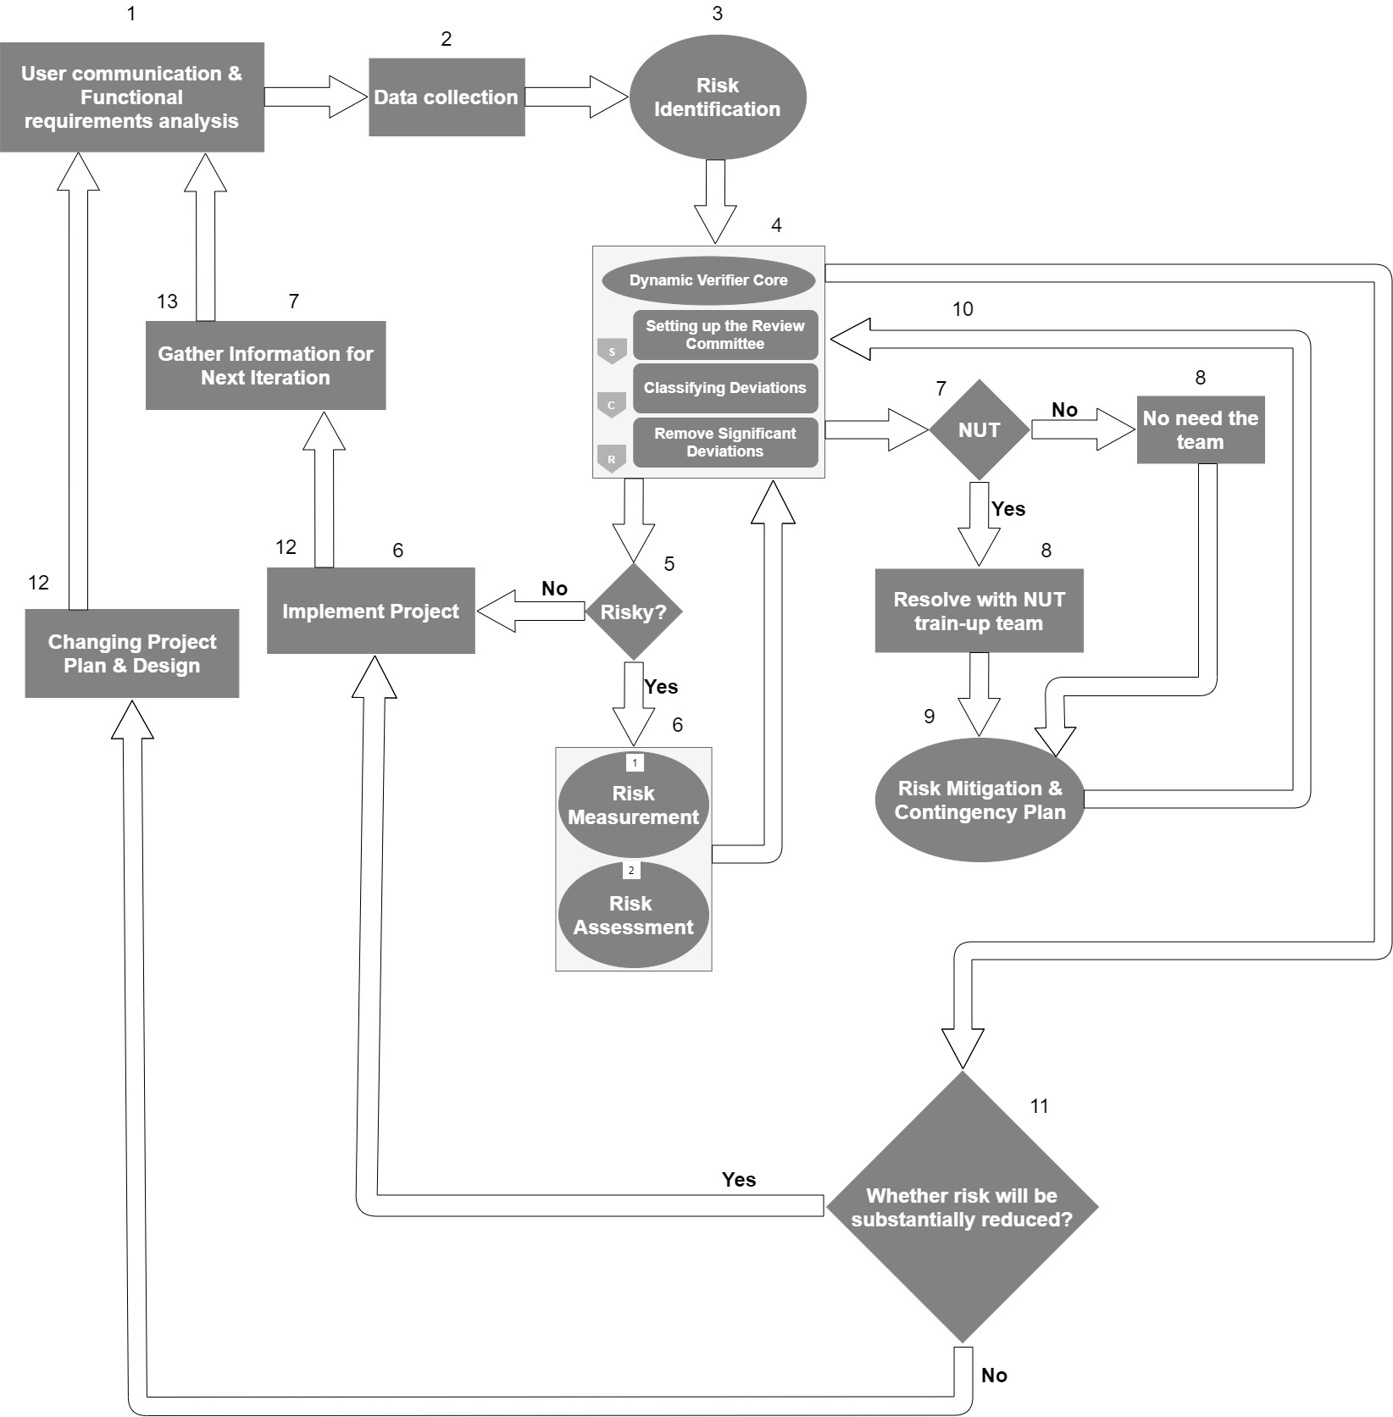

**Figure 3.3: Hybrid Model for Mitigating Risks**

# **3.3.1 Short Introduction of Proposed Model**

First, the model communicates with the users and tries to understand which functional requirements the user needs or more preferable in the User communication & Functional requirements analysis stage (step-1).

Through communication with users, the model analyses the user aspiration then it collects the data in the Data Collection stage (step-2).

Now the model knows the user needs or aspirations and so from the collecting data it identifies the risk in the Risk Identification stage (step-3). After the risk identification, it passes to the DVC (Dynamic Verifier Core) committee to verify the information of the risk identification stage.

The DVC (Dynamic Verifier Core) committee verifies with a review committee that concludes individual experts and developer representatives. The committee classifying the deviations by fuzzy questionnaires. Then it removes the significant deviations by developers under committee supervision if necessary (step-4).

After verifying the information of risk identification the DVC committee decides if the project is risky or not (step-5).

If the DVC committee does not find any risk from the information of the Risk Identification stage then the project will be implemented (step-6).

During the project implementation period, if any inconvenience occurs it will go for the next stage Gather Information for Next Iteration (step-7), and then the cycle complete as same as before.

If the DVC committee finds any risk from the Risk Identification stage then the project will go for the Risk measurement and Risk assessment stage (step-6).

After completing the risk measurement and risk assessment it passes again to the DVC (Dynamic Verifier Core) committee. Then the DVC will verify the updated information which the team got from the risk measurement and the risk assessment stage and then the team will provide feedback. From the DVC feedback, it will be decided that whether any new unproven technology needs to be used or not (step-7).

If no need to use any new unproven technology then no need for the NUT train-up team (step-8).

If the DVC decided that there is a need to use new unproven technology so resolve with the NUT train-up team (step-8) as the team is trained-up and also keep knowledge for previous records of risks that occurred for the lack of NUT train-up team.

After resolving it passes for Risk Mitigation & Contingency Plan (step-9).

After proper Risk Mitigation and Contingency plan, it passes to the DVC for verification (step-10).

After verifying, the DVC decides whether the risk is substantially reduced or not (step-11).

If the risk is substantially reduced then go for implementing the project (step-12).

During the project implementation period, if any inconvenience occurs it goes for the next stage Gather Information for Next Iteration (step-13), and then the cycle complete as same as before.

If the risk is not substantially reduced then change the project plan & design (step-12) and then the cycle complete as same as before.

# **3.3.2 Four Phases of Proposed Model**

We have proposed a hybrid model for mitigating risk. It has four phases - risk identification, risk measurement, risk assessment, and risk mitigation and contingency plan. To propose the model we gather knowledge from Boehm risk model and his classifications. We also collect the core idea from three papers of Ahdieh Sadat Khatavakhotan and Siew Hock Ow. In this proposed hybrid model we utilize the DVC as the core verification of risk management process [2]. The first phase achieve the collection of data. Depending on requirements the phase identify the fundamental risks by following certain significant steps and the risk factor agendas are arranged. The second phase estimated the danger elements' attributes by choosing the qualitative or quantitative method and create a measurement report. The third phase establishes and prioritizes the level of risk and afterward settles the assessment report and CTR graph. The fourth phase mitigates the risk by utilizing the "Synthesized Formula" and decides the effectiveness rate of risk mitigation. At last, drive the genuine risks and design an emergency course of action if the further risk has happened.

**Phase 1: Risk Identification**

The Risk Identification phase recognizes the sort and category of risks by following a few stages. After the risk identification, the risk will be measured in the following phases. The risk identification steps are described below:

1. Documentation Reviews
2. Brainstorming and interviewing
3. SWOT Analysis (STRENGTH, Weakness, Opportunities, and Threats)
4. Developing and analyzing agendas of dangers
5. Analysis of Root Sake
6. Creating the circumstances and logical results chart

Step 1: Documentation Reviews (Previous and present risk records):

The standard practice to identify risks is looking into project-related documents, for example, exercises learned, articles, authoritative process resources, and so on. The overview of all documentation reported risks in the past stage can compare the risk level also the probability of risks during exploration.

Step 2: Brainstorming and interviewing:

Especially, specialists in each part can give a clearer picture of the dangers. They can identify threats of different portion as well. This movement includes the need to have brief anyway critical gatherings with significant people, especially the subject matter experts, who are very much educated about the present and the past hazards [2].

Step 3: SWOT Analysis (STRENGTH, Weakness, Opportunities, and Threats):

Identify the strengths and weaknesses of the project. Recognizing project strengths and weaknesses will help to be clear about the opportunities and threats of the project. This procedure assists with identifying risk inside a greater organizational context. This technique uses as a planning tool for analyzing business, opportunities, and threats in the external environment, looking at internal strengths and weaknesses. This technique is additionally utilized in the formulation of strategy. This SWOT technique is incredibly compelling and fruitful for risk identification.

Step 4: Developing and analyzing agendas of dangers:

Fundamental and unambiguous plans ought to recollect the delayed consequences of studies for the past progresses, which give information on the title of the danger, the sort of dangers, and the IT project assets which might be feeble against the perils (counting business, specialized, time, and the executives dangers) [4].

Step 5: Analysis of Root Sake:

Root causes are resolved for the recognized risks. These Root causes are additionally used to distinguish extra risks.

Step 6: Creating the circumstances and logical results chart:

This is the main advance since it incorporates the identification of the reasons for a danger event and its results or its effect on the dangers [2].

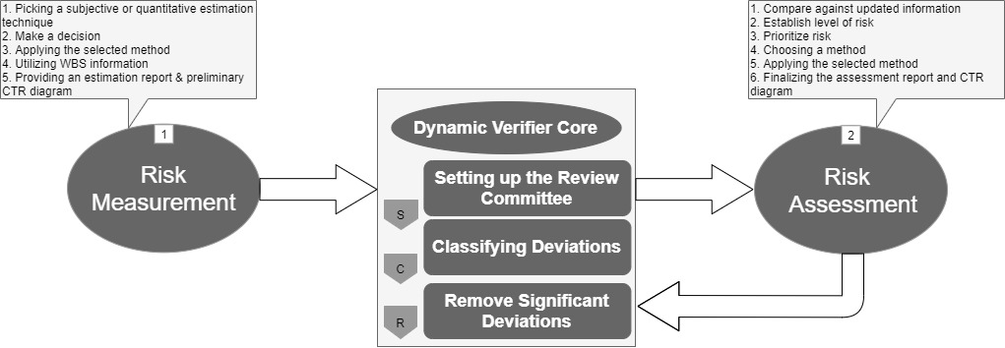

**Figure 3.3.2: Risk Measurement and Risk Assessment**

**Phase 2: Risk Measurement**

This phase deals with the fundamental characteristic of a danger – estimating or assessing to the degree a danger can impact the different pieces of a venture, work item, or final result. Thus, both subjective and quantitative strategies should be applied [2]. Nevertheless, these outlines essentially are removed from the conceptualizing, prior gatherings with the subject matter experts, and the connected writing. Especially this technique is moreover used for Work Breakdown Structure (WBS) for being seriously convincing and better execution. This shows the blend of qualitative and quantitative strategies. Stage 2 contains five stages:

1. Picking a subjective or quantitative estimation technique
2. Make a decision
3. Applying the selected method
4. Utilizing WBS information
5. Providing an Estimation Report & Preliminary CTR (Cost Time Risk) Diagram [2]

Step 1: Picking a subjective or quantitative estimation technique:

Quantitative research is more liked over qualitative research since it is more logical, unbiased, quick, centered, and adequate. Notwithstanding, qualitative research is utilized when the analyst has no clue about what's in store. It is utilized to characterize the issue or foster a way to deal with the issue. Quantitative research manages numbers and statistics, while qualitative research manages words and implications. Quantitative methods permit you to test a theory by efficiently gathering and breaking down information, while qualitative methods permit you to investigate thoughts and encounters top to bottom. Thusly, select an appropriate estimating technique ensuing to considering the characteristics of a danger that had been settled in the past stage where the data got in the genuine environment, the time and switching the limitation of budget, and different limits.

Step 2: Make a decision:

After choosing the appropriate measuring method by considering the data of risk identification make a decision whether it is applicable for applying or not.

Step 3: Applying the chose technique:

The Work Breakdown Structure (WBS) strategy for assessing chances is used in the proposed model [5]. This is in light of the fact that the development of the IT projects relies upon the requirements conclusions of each stage, rather than the genuine fragments. Along these lines, the information obtained from each section of an IT task will be sensible for hazard estimation and assessment [6].

Step 4: Utilizing WBS information:

Other than fast project breakdown in WBS, likewise gain admittance to instruments like Gantt, Resource and Task Management, Time Tracking, and Earned Value Management - accessible for individual use and groups.

These incorporated into one solution that follows Easy Project Management Philosophy:

* Abstract the project scenario "makes it Easy"
* Visualize it
* Plan it
* Manage tasks
* Evaluate it

In the estimating interaction, each hazard will be requested either as Catastrophic, Critical, or Marginal. Huge monetary lack or specialized execution are requested as disastrous dangers. Basic dangers wrap up minor deferrals in programming alterations and some danger alleviation in specialized execution; in any case Marginal dangers are irrelevant to a little danger decrease in specialized execution and monetary assets [7].

Step 5: Providing an estimation report:

The deliberate properties of the danger factors are added to the information in the past plans, and they will be evaluated and announced with different units of time, and cost [2].

**Phase 3: Risk Assessment**

Risk assessment is the first step toward effective risk management [2]. The risk assurance step will assign risk priority to each risk by contrasting the probability level (high, medium, low) and effect level. Risk management in expanded endeavor frameworks makes out of utilizing risk sharing, control and avoidance, and financial instruments to diminish the impacts of the coordinated operational chain chances and their financial consequences [8]. The risks will be assessed and positioned in this phase based on the information and estimates gathered in the previous phase. There will be considerable difficulties in allocating resources, planning, and deciding on an alternative course of action if the appraisal is inaccurate [9]. In phase 3, from the start, compare the refreshed data and past bits of risk records and set up the risk level at that point focus on them, pick a method to lessen the risk, apply the picked method, and finalize the assessment report and CTR diagram.

**Phase 4: Risk Mitigation and Contingency Plan**

The primary goal of risk management supervisors is to improve risk mitigation decisions. Other than risk reduction activities, it is necessary to address the mitigation of known risks, expected circumferential risks, arose opportunities, and amplified opportunities in order to make an effective decision [1]. This phase makes use of the data gathered in the preceding phase. This phase is divided into two parts: mitigation strategies and contingency plans. Phase 4's steps are as follows:

1. Identifying the hazardous risk
2. Characterizing plausible decision for risk mitigation
3. Deciding the activity for every decision
4. Diminishing the occurrence probability and results of risks
5. Applying the utilization of mathematical formulas:

* measure the advantages of the parallel impacts of each activity
* measure the recently arisen opportunities
* measure amplified opportunities
* select decisions dependent on the acquired results of the formulas
* states the ideal risk mitigation decision's efficiency rate

1. Driving the actual risks
2. Designing Contingency Plan [2], [1]

**Decisions for the Best Mitigation:**

The following steps are included in the model that optimizes risk mitigation decisions [1]:

To begin, the model has identified significant risks from the previous phase. From there, the model will define likely risk mitigation decisions and determine the activities for each option, including actions that reduce risk occurrence probability and actions that reduce risk outcomes after they have occurred. Utilize the application of mathematical formulas to measure the advantages of the sidelong impacts of each activity and furthermore measure the recently arisen opportunities and amplified opportunities from the past phases of the project. Finally, select decisions dependent on the acquired aftereffects of the formulas.

**Synthesized Formula:**

The proposed formula for this model is termed the 'Synthesized Formula,' and it declares the risk mitigation optimum decision's efficiency rate [1].

Whereas:

EDi = ED*A*i – GICA

**Variables and descriptions:**

GICA = General Inconvenient Consequences Amount regarding decision i

EDAi = Efficiency of Decision i regarding the Actions

EDi = Efficiency of Decision i

Ck = Cost of action k

RRAk = Risk Reduction Amount regarding action k

RRA_Netk = RRAk Considering its Probability

OICAk = Other Inconvenient Consequences Amount regarding action k

OICA_Netk = OICAk Considering its Probability

OBAk = Opportunity Benefit Amount regarding action k

For each key decision, this formula takes into account the risk mitigation likelihood as well as the rate of consequence reduction. Simultaneously, the activities' likely opportunities will be calculated in detail. Finally, for each action, the chance and loss amount of circumferential risks will be computed. By focusing on the cost of each activity, the algebraic total of the previously described issues reveals the effectiveness of each action.

Driving the actual risks: If a risk has occurred, the contingency plan of action will be implemented. The agendas and reports are sent to the DVC at the same time in order to start the major changes.

Creating a contingency plan: If a risk occurs, the plan indicates what actions should be taken to mitigate the consequences, based on the risk characteristics [2].

# **3.3.3 DYNAMIC VERIFIER CORE (DVC)**

DVC can be broken down into three parts, as shown in Figure 2. Without considering the pre-owned strategy, the pre-arranged reports, computations, and documents are delivered to DVC core to analyze and detect likely deviations from objectives, programs, and actions at the end of each level in the risk process. Finally, the necessary steps for preventing such errors will be taken. DVC is broken down into three steps [10]:

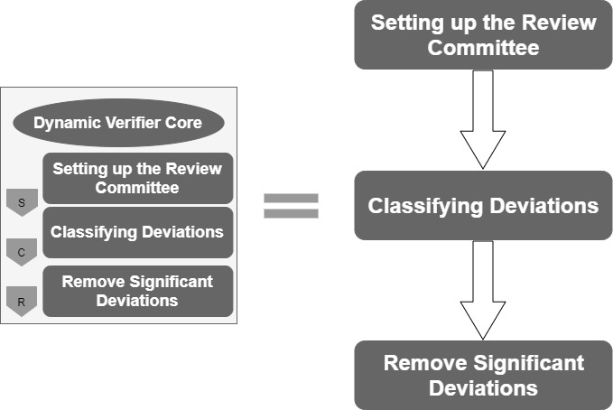

**Figure 3.3.3: DVC (Dynamic Verifier Core)**

The review committee is made up of a few individuals with distinct capabilities who have distinct responsibilities at different stages. Considering the aforementioned difficulties, the review committee, essential personnel, should be involved at the end of each phase of the risk process, such as risk identification, measurement, assessment, mitigation, and contingency planning. The data is sent to the DVC using pre-planned structures whenever each phase is completed. During the review, any probable deviations were classified. Finally, the committee decided to remove the significant deviations from the checklist and revise it

# **3.3.4 Unique Feature of the Proposed Model**

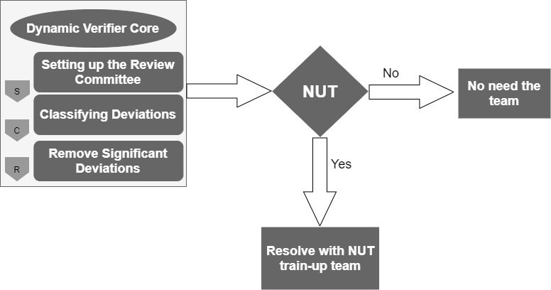

**Figure 3.3.4: NUT train-up team**

**NUT (New Unproven Technology) train-up team:**

The unique team (DVC) will be considered and verified the three phases of risk characteristics and declared whether the new unproven technology is necessary or not. If the risk will be reducible without using the new technology, then no need the NUT train-up team. If the new technology is necessary then follow the below steps:

1. Make a team by providing proper training on each new-unproven-technology so that the train-up team can properly use the new technology.
2. The team has to keep proper information/knowledge about the previous and present risk impact areas records.
3. Identify the type of technology.
4. Compare with previous and present risk records for new unproven technology.
5. Resolve the technical problem.
6. Pass the updated solution to DVC (Dynamic Verifier Core).

# **CHAPTER 4: RESULTS AND ANALYSIS**

# **4.1 Survey Results**

Our survey questions were created in a sequence so that we can relate with the previous literature reviews and proposed a risk model depending on the survey results. So, after getting all the responses we related with the previous literature reviews and we have already identified the risk impact areas depending on our survey results in the Research Methodology and proposed a risk-mitigating model. In this part, we will exhibit the information investigation and explanation of survey results:

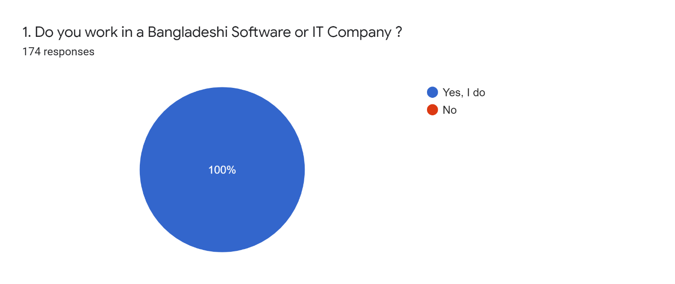

**Figure 4.1.1: Representatives Details**

We had conducted a survey for our research paper. We sent the survey to various IT and software related companies in Bangladesh. We received a total of 174 responses on this survey. Since our initial inquiry was, "Do you work in any software or ID company in Bangladesh?" As a result, we get 100 percent yes responses.

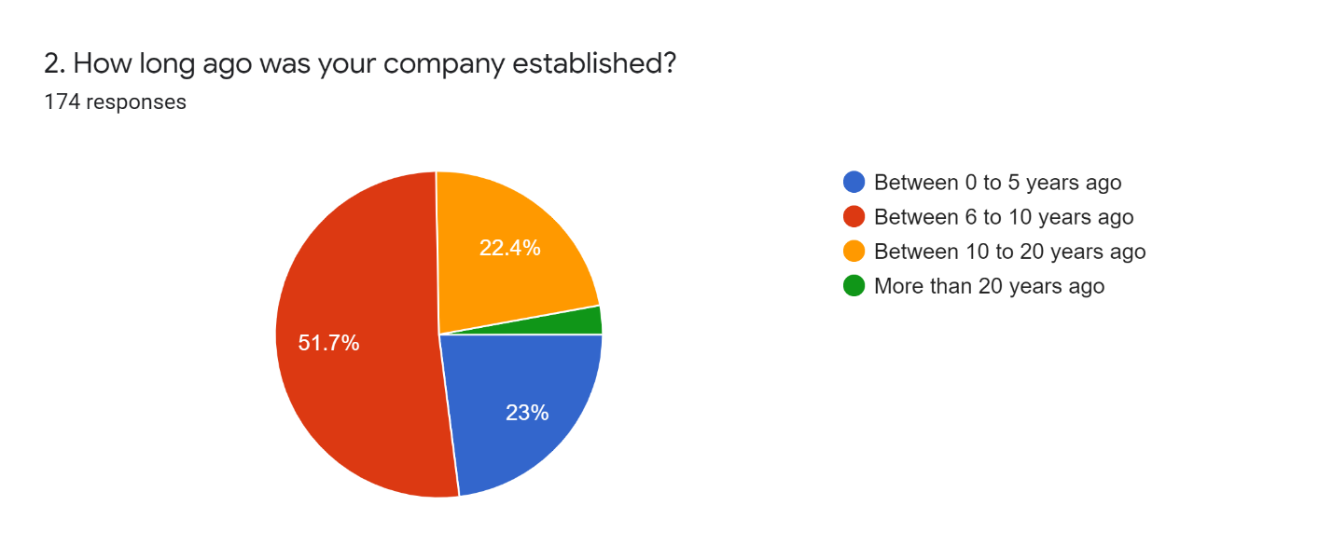

**Figure 4.1.2: Information about the company's Establishment**

Our second question was exactly how long ago your company was established. We have received a variety of opinions on the answer to this question. In five years from zero, we got the answer 23 %. In six to ten years we have got 51.7 %. In 10 to 20 years we got 22.4 %. And over 20 years we’ve got 2.9%. In the context of Bangladesh, the IT and software sector revolutionized in 6 to 10 years. Which we can see from our pic chart. The motive behind our question was how long ago the company was stubborn because the age of the company is very important for a survey. The age of the company can provide most previous ideas or records.

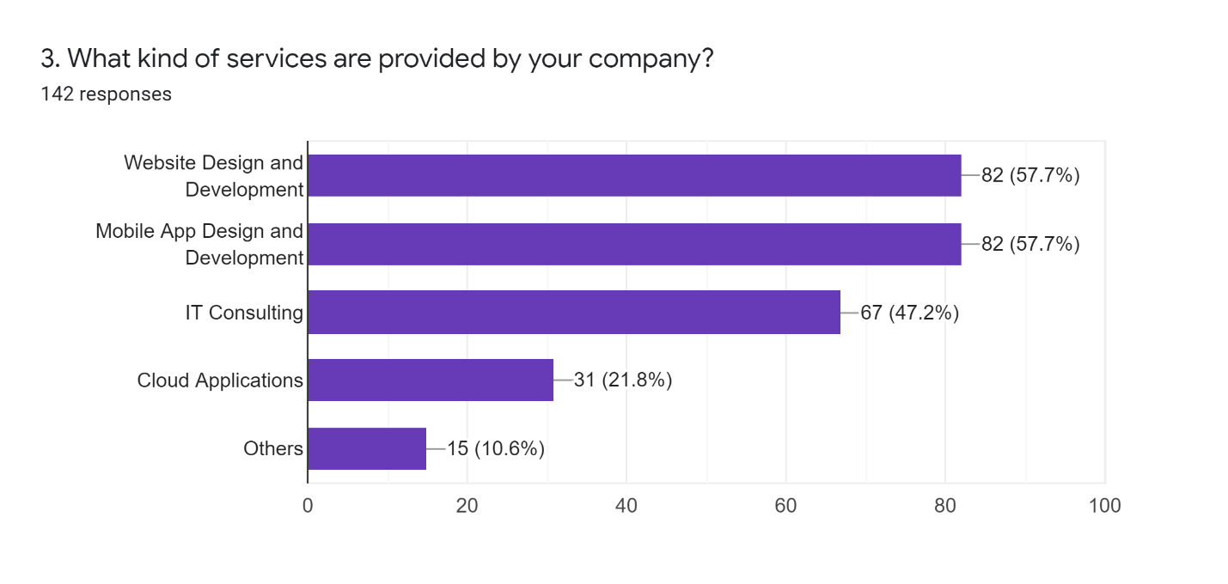

**Figure 4.1.3: Information about the Company's Services**

We asked the companies in Bangladesh what kind of services they provide. Then we notice web design and development 57.70 %. And close to the mobile application and design development i.e. 57.70 percent. The remaining 47.2 % are IT consulting, 21.8 % are cloud applications and 10.6 % are others. Through this, we understand that most of the IT and software companies in Bangladesh provide services on web development and mobile applications.

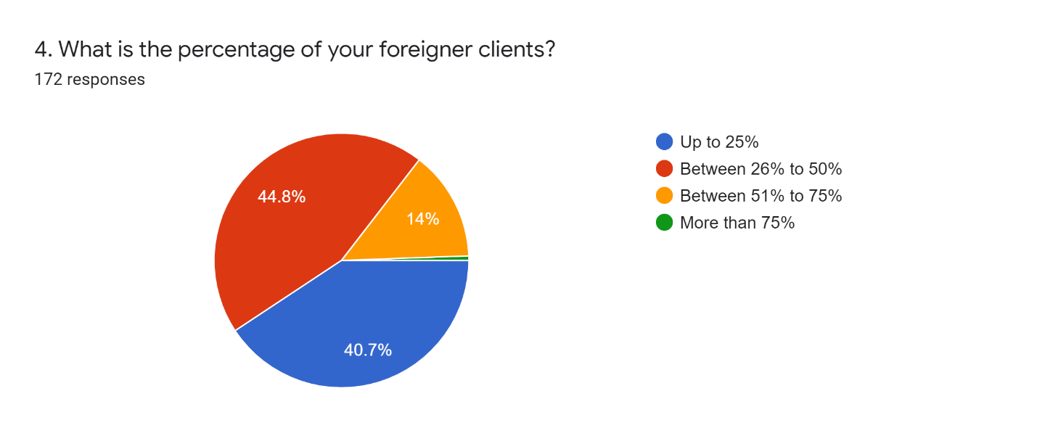

**Figure 4.1.4: Information about Foreign Clients**

Keeping pace with the times, Bangladesh now works with its customers in foreign countries as well. So our question was how many outside clients companies have. Through the survey, we get some mixed answers. 40.7% external clients in some companies. Again in some companies 44.8 %. And the remaining 14% in various companies. We make the question 25%, 50%, 75%, and more than 75% this way, respectively. If a company faces foreign clients also the company is suitable to provide the global factors practically. Especially their global communication helps to gain knowledge for global client's requirements.

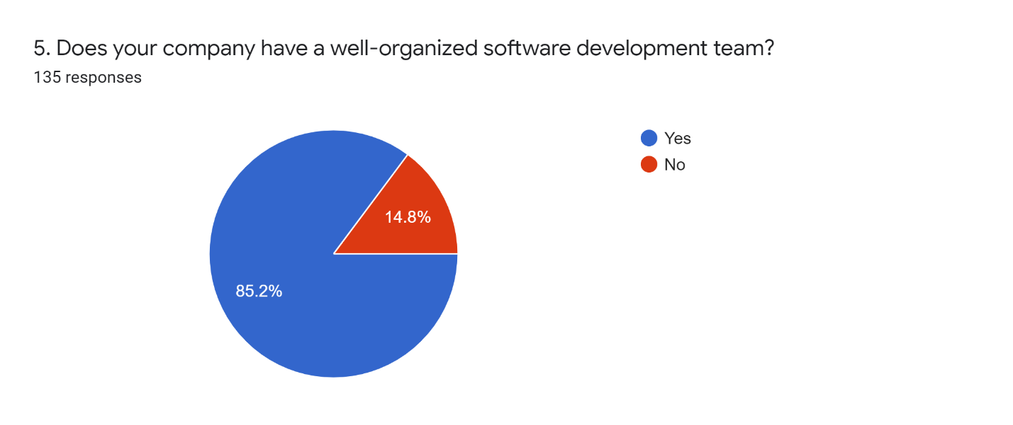

**Figure 4.1.5: Structure of Development Team**

In our survey, we questioned is there a well-organized Software Development team between software companies and IT companies? Of which we received feedback from 135 companies. Of these, 85.2% got the answer Yes. And received 14.8 percent of the answers are No. A well-organized team is a prerequisite in case of software project development otherwise there is a risk of project failure. Therefore, companies should focus on different risk factors and whether the software development team is well-organized or not.

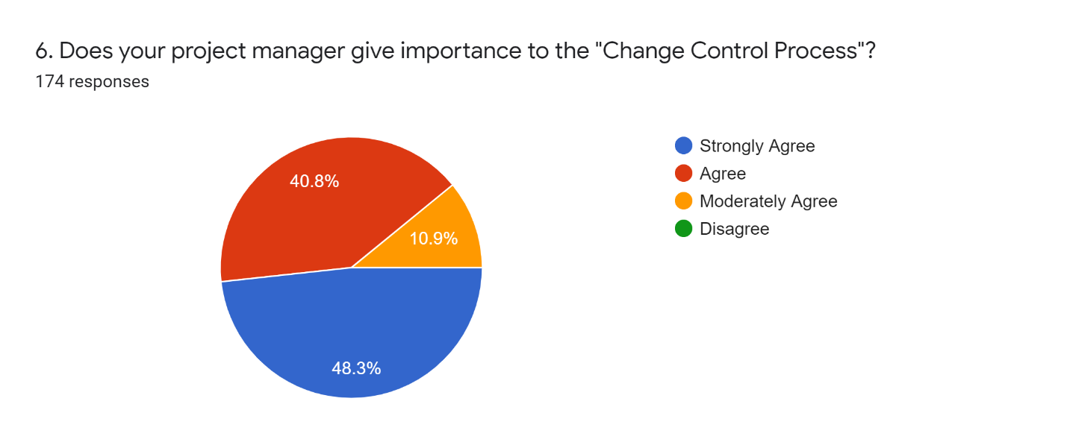

**Figure 4.1.6: Details of Change Control Process**

Change control is of particular importance when the project is part of a larger program or portfolio because the consequential effects of unmanaged change may be far-reaching within the planned change environment and to business-as-usual activities. Software and IT companies have some rules or procedures. Following this, we asked Does Your Project Manager Give Importance to Change Control Process? We received 174 responses of which 48.3% strongly agreed. 40.8 percent agreed. Moderately agreed 10.9 %. Through this, we have concluded that about 99% of companies insist on the change control process.

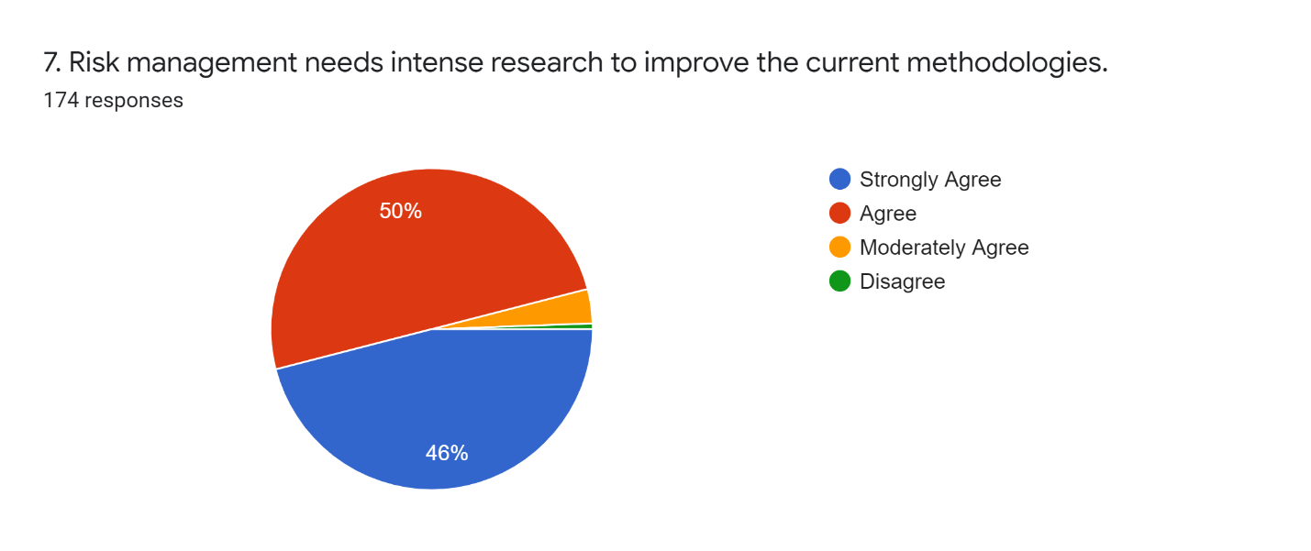

**Figure 4.1.7: Feedback Current Methodology**

We get different opinions from the survey on the need to further strengthen the research on risk management among the current methods. Of which 46% strongly agreed and 50% agreed and moderate agree was 3% and the remaining 1% do not think so. Risk Management requires further more research as software companies everyday face for software risks and software failure happen in each IT Industries.

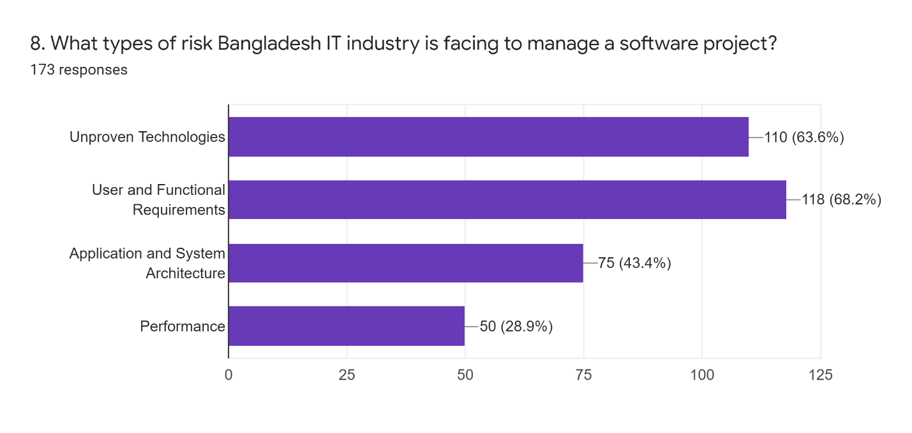

**Figure 4.1.8: Information about the Risk of Bangladesh IT industry**

Numerous challenges face software and IT companies in Bangladesh, including unproven technologies, user and functional requirements, application system architecture, and performance. Unproven Technologies account for 63.6 percent, User and Functional Requirements account for 68.2 percent, Application and System Architecture account for 43.4 percent, and Performance accounts for 28.9 percent. We see that one of the biggest problems that software companies face is user and functional requirements. What a software project will look like depends on the client's requirements. Software projects often go unnoticed due to a variety of reasons, such as not being able to understand what the client wants and not being able to understand what the client actually wants. To address all of these issues, some structural changes in the company and more emphasis on client requirements analysis and understanding are needed.

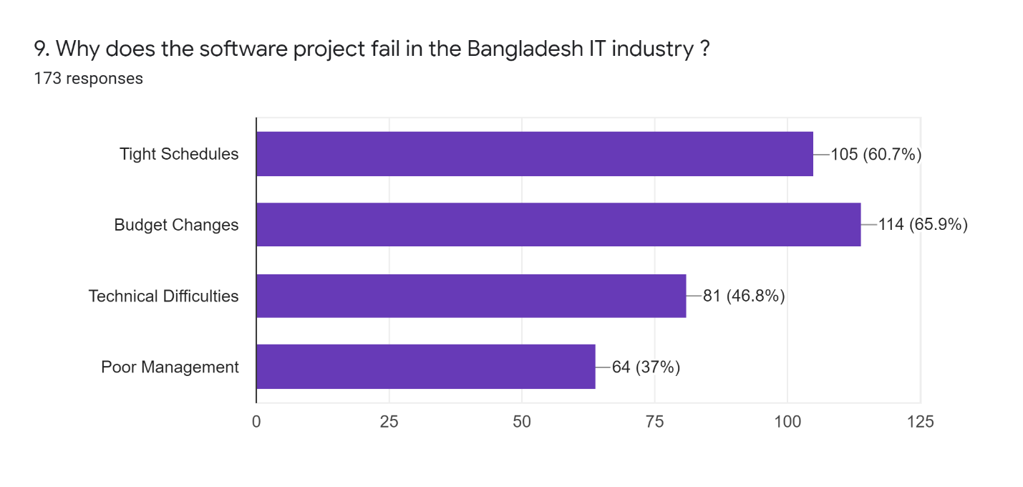

**Figure 4.1.9: Feedback about Project Failure**

According to the data in this table, the majority of software projects fail due to budget changes and tight deadlines. We keep some common causes of software failure as options in our survey question. We can see from their responses that the company representative agrees with us. Budget can help project managers to use the budgeting process as a tool to aid in communication and planning. The budget serves as the foundation for all project activities. It provides the resources required for year-round planning. The budget ensures that departments and initiatives can continue to operate. The project schedule is a calendar that connects the tasks that must be completed with the resources. Before creating a project schedule, the project manager must have a work breakdown structure (WBS), an estimate of effort for each task, and a resource list with availability for each resource.

Technical difficulties and poor management have also elicited a large number of responses from company representatives. Every technological advancement is a blessing to the information technology industry. At the same time, technology is evolving at a breakneck pace, putting additional pressure on software development professionals to leverage these upcoming technology trends in software product development to gain a competitive advantage and stand out in the market. Project management has been the focus of much recent attention because of the enormous penalties incurred during software development and maintenance resulting from poor management. So proper project management is very important.

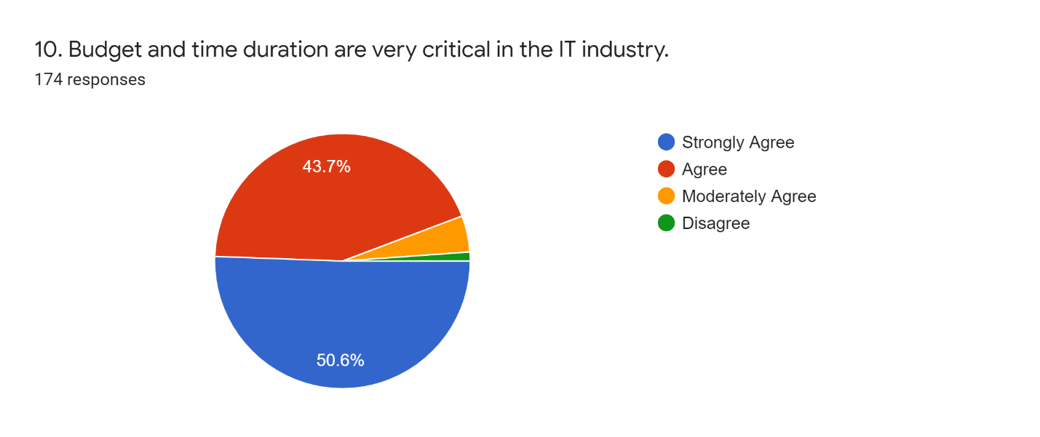

**Figure 4.1.10: Information about Budget and Time**

According to the above pie chart, 50.6 percent of people strongly agree and 43.7 percent agree that budget and time duration are very important in the IT industry. Budget is at the heart of every project. If you had a larger budget, you could probably hire more people to complete your project faster and deliver more. As a result, no project plan is complete until a budget is developed. But, regardless of how large or small your project is, or how many resources and activities are involved, the process for determining the bottom line is always the same. The project schedule is a calendar that connects the tasks that must be completed with the resources and deliver the project on time is very important for the IT industry.

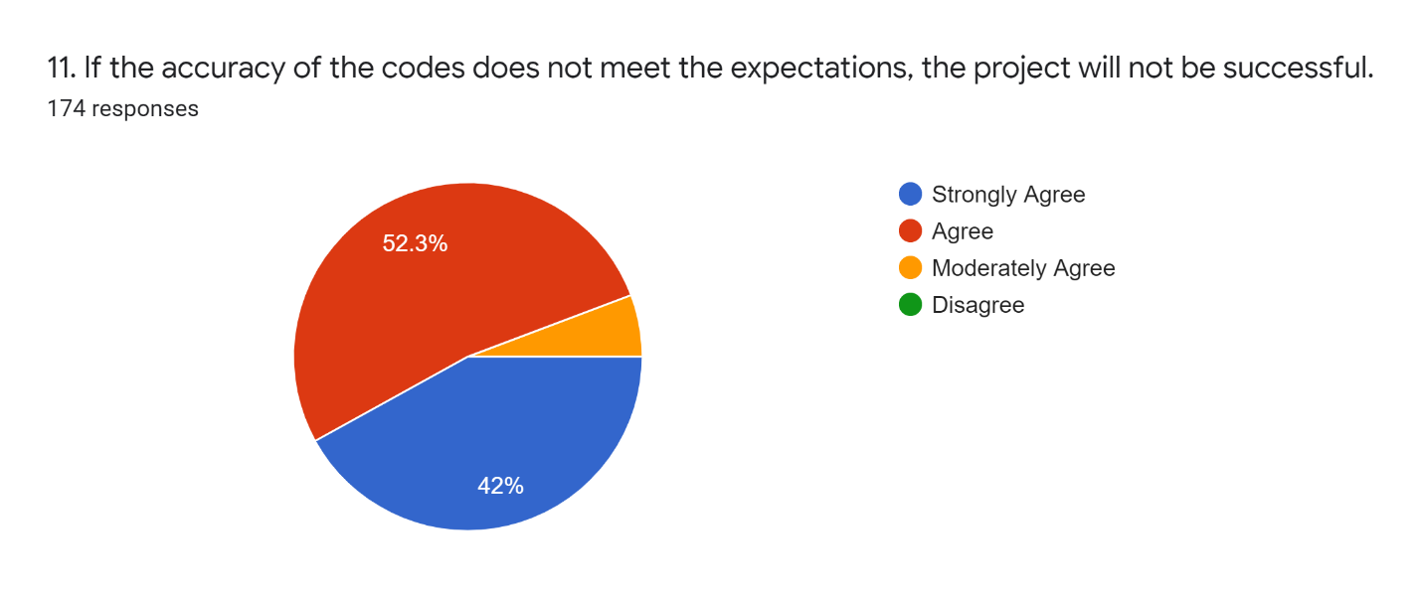

**Figure 4.1.11: Feedback on Code Accuracy**

According to the pie chart, a significant number of people believe that coding accuracy is crucial to the success of a project. Coding accuracy aid in the development of less complex software programs, reducing errors. If the coding standards are followed, the code is consistent and easy to maintain. This is due to the fact that anyone can understand it and change it at any time.

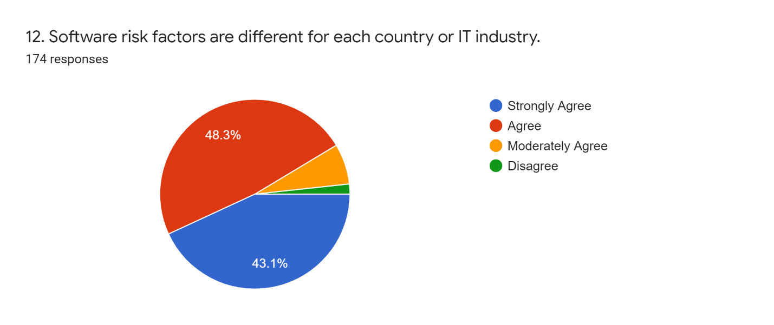

**Figure 4.1.12: Information about Software Risk Factors**

The pie chart shows that 48.3 percent of people agree and 43.1 percent of people strongly agree that software risk factors are different for each country or industry. We also found the difference when we were doing our background researches. We found that budget, the quality, and experience of manpower, insufficient training, insufficient resources are the main reasons behind that.

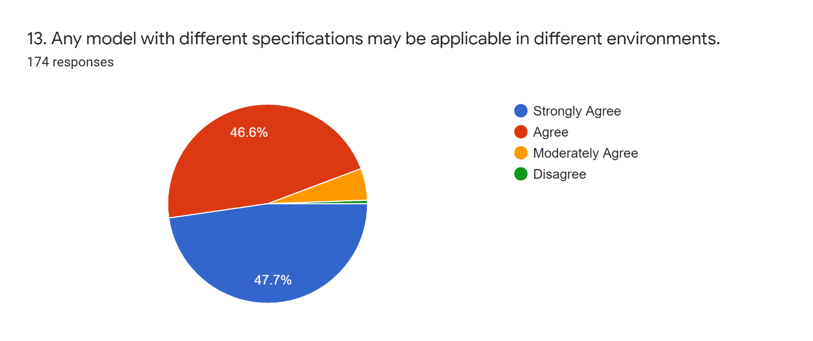

**Figure 4.1.13: Feedback on Model Different Specifications**

According to the above pie chart, most people agree that any model with different specifications may be applicable in different environments. In most software development processes, requirements specifications are a critical artifact. They capture the objectives of the software to be developed and serve as the link between the customer and the developers. Many consider specifications to be the deciding factor in project success or failure. However, requirements specifications, like any other development artifact, contain redundancy. Semantic redundancies are the source of many potential problems in a development project but are also extremely hard to detect.

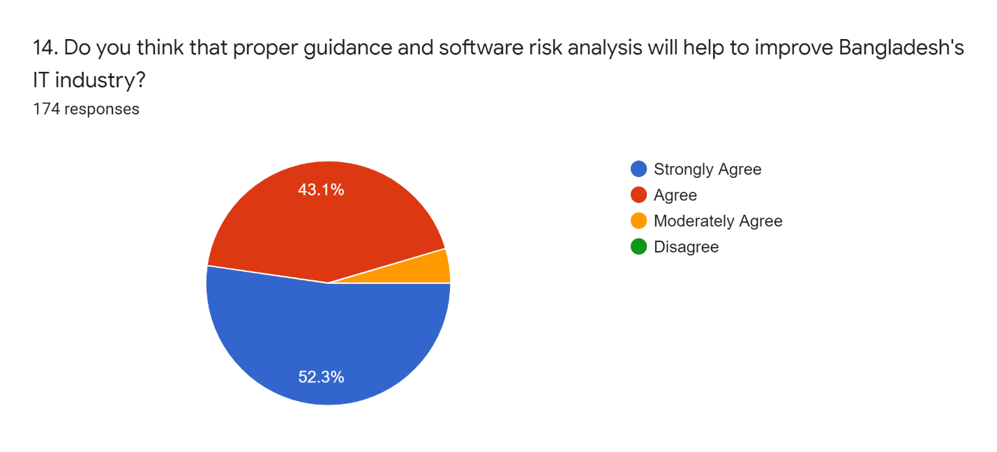

**Figure 4.1.14: Feedback on Proper guidance and Risk Analysis**

According to the pie chart, the majority of people believe that proper guidance and software risk analysis will improve the Bangladesh IT industry. According to the pie chart, 52.3 percent of people strongly agree and 43.1 percent agree. Because we want to propose a model for identifying and analyzing software risks, the feedback encouraged us to complete our work.

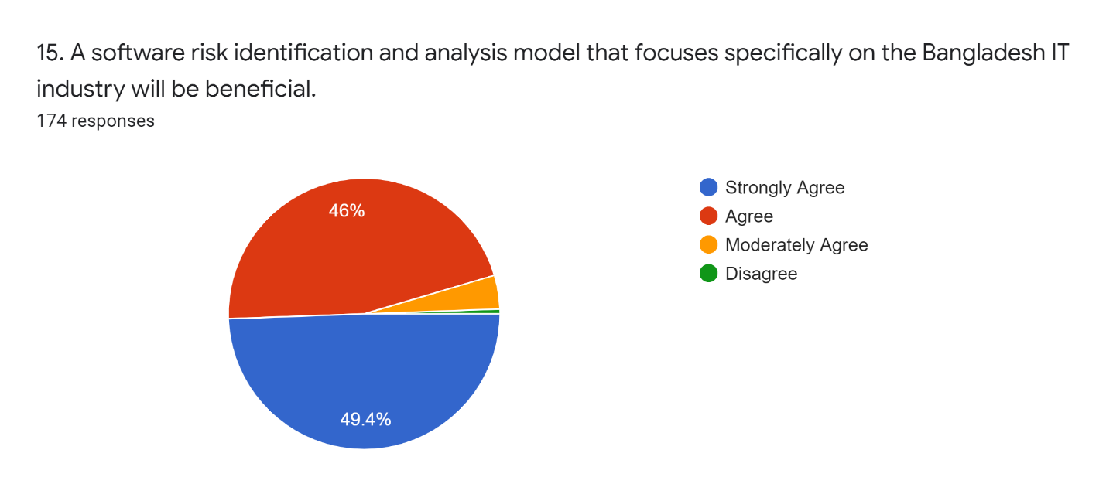

**Figure 4.1.15: Feedback on the Creation of a New Model**

According to the pie chart above, the majority of Bangladeshi software company representatives want a risk identification and analysis model that is specific to the Bangladeshi IT industry. We also believe that a new model should be introduced for the Bangladesh IT industry because of that in our thesis book we suggest a new risk identification and analysis model that is specific to the Bangladeshi IT industry.

# **4.2 RESULT ANALYSIS**

By analyzing all the replies to our survey questions, we have found some factors that are coming multiple times and related directly or indirectly to other factors. Risks are for the most part considered as autonomous events in risk management approaches. Nonetheless, practically speaking, the risks of a field may influence the risks of different fields. For instance, the scheduling risks have common impacts with budget and cost risks. Therefore, considering the conditions in risk management prompts an increment in the performance of the models [1]. From our survey results, we can see that the New Unproven Technologies, User and Functional Requirements, Tight Schedules, and Budget Changes are the significant risks and those risks are the most irritating obstacles to the success of software projects. We have effectively gone through the literature and proposed a model for risk mitigation of Bangladesh IT Industry. Thus, we are certain about some facts with respect to terrible practice and genuine responsibilities. And so, based on the overall justifications, here we have provided some suggestions to handle the software project risks for some risk impact areas.

# **4.3 Suggestion of reducing risk for some risk impact areas**

**1. Tight Scheduling:** Tight Scheduling consistently raises the stress of anxiety and subsequently gradually the project fall towards the risk. Be that as it may, with a little planning and shuffling, the apparently incomprehensible can be made conceivable. So here are five hints to help you comply with those threateningly tight deadlines constraints and hold your stress of anxiety under tight restraints:

* **Clear your plan for getting work done:** Start by clearing your timetable and daily agenda of anything that is certainly not a high need. This may mean putting other significant however less pressing activities and assignments on hold to comply with the time constraint. Remember that your experience, mastery, and sincere goals will not assistance at all in the event that you don't have the opportunity to focus on it.
* **Get help all along:** If work is furious and you realize you will battle to comply with your time constraints look for help all along, don't leave it until the latest possible time.

Brief your colleagues or re-appropriated group about your project and what you will (or may) need them to do so they are prepared when you need them. This will save time and guarantee work is initiated rapidly and done profitably. Make certain to work in a cushion cutoff time for your group so you have additional opportunity to reexamine and make changes if necessary.

Additionally ensure you get more assistance on the home front, sharing or rethinking a greater amount of your household tasks to save more opportunity for work to fulfill the time constraint.

* **Break the project down:** Don't attempt to handle the whole project at the same time, separate it into more modest, more sensible errands and have cutoff times for every one of them to keep you on time. This will assist with holding your stress of anxiety under wraps.
* **Work on it slowly and carefully:** Once you have separated the project into more modest errands, center around the first. At that point just once it is finished move onto the following task. Verifying each task as it's done will give you the inspiration to continue onward and assist you with effectively keeping tabs on your development.
* **Have a disclaimer in proposition and statements:** If you discover you're conveying various recommendations or statements on the double, put a date on how long they are legitimate for and incorporate a disclaimer that the beginning date might be affected because of your plan for getting work done at the time it is acknowledged.

These give you some additional breathing space on the grounds that while you may have time in your timetable when you convey the statement on the off chance that they acknowledge it three weeks later, you may be run off your feet.

2. **Budget Changing:** Double check that your team knows about the specific necessities of the project. Converse with them about the change control interaction and how they ought to only work on what is endorsed. In the event that the rundown of necessities continues to climb, it's an ideal opportunity to make a stride back and investigate which changes will prompt a superior result, and which ones will not. The key is to remain as near to the first objectives and destinations of the favorable to project, without settling on yield quality [19].

**3. Technical Difficulties:** In such situations, risk management plays an essential part. Identifying the specialized dangers in programming improvement projects, their effect, remediation, and checking become the most noteworthy need. You can begin by recognizing and documenting the controls as of now set up to deal with the distinguished dangers. The dangers remaining after these controls, otherwise called lingering chances, should be tended to while de-marking your procedures. These techniques are known as hazard alleviation systems. Hazard moderation may imply at least one of the accompanying – moving the danger to an external party, financing it, staying away from it totally, or tolerating it. Fostering the correct methodologies will help oversee risks to an adequate level. Toward the day's end, the objective is to relieve the dangers to where the expense of mitigation exceeds the potential advantage [19].

**4. Poor Management:** The correct project manager will actually want to effectively design devise systems that guarantee that the dangers related with the task are limited. Further, by rehearsing compelling correspondence with the groups, fabricating a solid authoritative system, and executing elaborate documentation measures, the level of ventures that fall flat can be fundamentally diminished [19].

# **4.4 Solution Verification**

As our target was to mitigate the risk of software projects of Bangladesh IT Industries firstly, we have found out the risk impact areas and analyze them which are responsible for the failure of software projects through a survey on Bangladesh IT Industry. Secondly, from the replies to the survey, we have classified and identified the risk impact areas and relate them with the previous literature reviews. After the overall views and justifications, we have suggested some risk impact areas which are mostly responsible and irritating obstacles for software projects. Thirdly, we have proposed a risk mitigation model. In this model, we have notified the phases of risks and DVC verifies each phase. After the verification of DVC, the same team decides whether risk happened or not and what should be avoidable, or what should be includable. We have noticed from our survey and the previous literature reviews, when the software projects face the necessity of new technology then for the lack of proper training on new technology most of the software projects do not go ahead towards success, they failed in the middle. In this model, we have included a new feature that is NUT train-up team. The DVC also decided that whether the use of new unproven technology is necessary or not. If necessary then NUT train-up team will solve the related problem by using their previous and present knowledge and then the DVC will verify the results again and provide a decision. As a result, software project failure will be reduced substantially as a proper train-up team is frequently training up on new technology. Furthermore, as a unique team (DVC) check and decide for each and every risk phase and stage so the possibility of decision mismatch will be reduced substantially. Additionally, the proper user communication and functional requirements analysis happened in this model. The Synthesized Formula declares the risk mitigation optimum decision's efficiency rate [1]. Finally, the goal of risk mitigation is successful.

# **4.5 Advantages of Proposed Model**

The proposed model has the following advantages:

1. The model follows a sequential manner. If one stage is done it goes to the next stage. So the model simply follows a simple path and it has simplicity.
2. It has transparency for new technology. NUT train-up team training up continuously for new technology and so the model has an effective solution for new technology that is ignored in the previous models.
3. Each phase is verified by the same people and there is no chance for decision mismatch.
4. The model concern about user communication and functional requirements.
5. The transparency of each phase and the gradual occurrence of the risk impact areas [2].
6. It is a comprehensive model as it covers all stages from identification to implementation, to mitigation and contingency planning [2]
7. There has a chance for changing the project plan and design before the failure of software projects.

# **CHAPTER 5: CONCLUSION AND FUTURE WORK**

# **5.1 Conclusion**

Our goal was the reduction of software risk in Bangladesh IT Industry. Basically, the model has conducted our goal through two teams i) DVC (Dynamic Verifier Core) and ii) NUT train-up team. The DVC demonstrates the four risk phases and suggests decisions. The NUT train-up team facilitates for the new technology which is basically ignored in the other models. To take risk mitigation decisions we have used “Synthesized Formula” in Phase 4 (Risk Mitigation and Contingency Plan) [1]. The use of “Synthesized Formula” has strongest the model to mitigate the risks. The Synthesized Formula declares the risk mitigation optimum decision's efficiency rate [1].

However, the model identifies the possible risks in all stages of the software development process so that a proper mitigation strategy can be adopted at the appropriate level to reduce the possible financial and temporal loss.

# **5.2 Limitations and future possibilities**

In this paper, we have proposed a model for the purpose of mitigating the risk of software projects depending on a survey of the Bangladesh IT Industry. We took the idea by going through the previous literature reviews and have picked up the risk impact areas from the survey which are the responsible most for software failure and tried to reduce those risk impact areas by the proposed model. Our proposed model needs two teams one is DVC another one is NUT. For the two teams, there is needed for large human resources. For the NUT train-up team, we need extra human resources and sometimes the team has no work if not necessary to use new technology for developing the software project.

As we have done our survey for specific software companies and got the idea for recent risk areas so we believe that this model can be more perfect if the future researchers could reach a greater number of companies by their survey. They can also fix the limitations of this model. It will be much better if the researchers could manage face-to-face interviews and convince the software companies to reveal the correct reasons, share their documentations, and have some honest talks about software failure.

**CHAPTER 6: REFERENCES**

# **6.1 References**

|  |  |
| --- | --- |
| [1] | A. S. Khatavakhotan and S. H. Ow, "Rethinking the Mitigation Phase in Software Risk Management Process: A Case Study," in *2012 Fourth International Conference on Computational Intelligence, Modelling and Simulation*, Kuala Lumpur, 2012. |
| [2] | A. S. Khatavakhotan and S. H. Ow, "DEVELOPMENT OF A SOFTWARE RISK MANAGEMENT MODEL USING UNIQUE FEATURES OF A PROPOSED AUDIT COMPONENT," *Malaysian Journal of Computer Science,* vol. 28, no. 2, pp. 110-131, 2015. |
| [3] | S. G. Sutton, D. Khazanchi, C. Hampton and V. Arnold, "Risk Analysis in Extended Enterprise Environments: Identification of Critical Risk Factors in B2B E-Commerce Relationships," *Journal of the Association for Information Systems,* vol. 9, no. 3-4, pp. 151-174, 2008. |
| [4] | D. Wu and D. L. Olson, "Introduction To The Special Section On Optimizing Risk Management Methods And Tools," *Human & Ecological Risk Assessment,* vol. 15, no. 2, pp. 220-226, 2009. |
| [5] | J. G. Zhao, "Significance Of WBS In Contingency Modelling," *AACE International Transactions,* pp. 5.1-5.5, 2006. |
| [6] | M. BETTER, F. GLOVER, G. KOCHENBERGER and H. WANG, "SIMULATION OPTIMIZATION: APPLICATIONS IN RISK MANAGEMENT," *International Journal of Information Technology & Decision Making,* vol. 7, no. 4, p. 571–587, 2008. |
| [7] | B. W. BOEHM, "Software Risk Management: Principles and Practices," *IEEE Software,* vol. 8, no. 1, pp. 32-41, 1991. |
| [8] | A. M. Sharif and S. Basri, "Software Risk Assessment: A Review on Small and Medium Software Projects," *J.M. Zain et al. (Eds.): ICSECS 2011, Part II, CCIS 180,* p. 214–224, 2011. |
| [9] | C. Radut, "The Enterprise Information System And Risk Management," *Annals of the University of Oradea, Economic Science Series,* vol. 18, no. 4, pp. 1030-1034, 2009. |
| [10] | A. S. Khatavakhotan and D. S. H. Ow, "Improving IT Risk Management Process by an Embedded Dynamic Verifier Core: Towards Reducing IT Projects Failure," in *2012 Third International Conference on Intelligent Systems Modelling and Simulation*, IEEE, 2012, pp. 684-687. |
| [11] | C. G. Pan, Y. W. Chen and W. Hao, "Overview of the study on theories and methods of software project risk management," Control and Decision, vol. 22, no. 5, p. 481-485, 2007. |
| [12] | A. Y. Abdihafid, Software Project Failure in Bangladesh, Daffodil International University, 2019. |
| [13] | W. T. LI, Z. Jian and Y. X. WANG, "Research on Software Risk Assessment Based on Grey System Theory," *Computer Technology And Development,* vol. 23, no. 5, pp. 124-126, 2013. |
| [14] | P. C. Yong and M. Phil, "Software Risk Management based on Software Development Life Cycle," Thesis of Zhejiang University, Zhejiang, pp. 11-17, 2002. |

|  |  |
| --- | --- |
| [15] | N. C. Pa and B. A. Jnr., "A Model of Mitigating Risk For IT Organisations," in *2015 4th International Conference on Software Engineering and Computer Systems (ICSECS)*, Kuantan, Pahang, Malaysia, IEEE, 2015, pp. 49-54. |
| [16] | M. Jakub and J. Gorski, "Software support for collaborative risk management," in proc. of 8th International Conference on Advanced Computer Systems, 2001, pp. 17-19. |
| [17] | B. Roy and R. Dasgupta, "A study on software risk management strategies and mapping with SDLC," in Advanced Computing and Systems for Security, Springer, 2016, pp. 121-138. |
| [18] | D. Reifer, "Ten deadly risks in Internet and intranet software development," IEEE software, vol. 19, no. 2, pp. 12-14, 2002. |
| [19] | "4 COMMON RISKS IN SOFTWARE DEVELOPMENT PROJECTS," The Scalers Consulting Limited., 2021. [Online]. Available: https://thescalers.com/risks-in-software-development-projects/. [Accessed 19 May 2021]. |
| [20] | S. Jena, "Different types of risks in Software Project Development," GeeksforGeeks, 26 August 2020. [Online]. Available: https://www.geeksforgeeks.org/different-types-of-risks-in-software-project-development/. [Accessed 19 May 2021]. |
|  |  |